# MIS 275 – Lab 1

In this lab, you will be installing Microsoft SQL Server and Visio. As a class we will go over functions and features to this database management system (DBMS). Some of you may already be familiar and have this software, if you do please be patient, others may not have any experience. As I keep this in mind I will be covering the material as if you have no experience with the software.

After you have completed this lab, you will need to upload this document to Canvas in order to get points for completing the activity. Save your document with the following naming convention:

* Course_Activity Number_First Initial Last Name (Example: MIS275_Lab1_LStewart.docx)

Install SQL Server 2016 or Above (Developer or Enterprise)

Download SQL Server 2016 using your Microsoft Alliance Azure account or install folder from Canvas. Refer to the Setting Up Azure Account document on Canvas for more information.

You will also need to make sure to install Microsoft Management Studio. You will be able to find the download for that within the SQL Server Installation Center.

Murach SQL Server Management Studio Exercises 1 – 6 on page 81

1. Download AP database folder from Module 1 in Canvas.
2. From the File menu in SQL Server Management Studio, Open the AP database sql script files.
3. Select the Execute button to run that script that creates the database and its tables.
4. Review the structure of the tables and the data in the AP database.
5. To show you’ve completed this activity, paste a screen print under this question of the SQL Server Object Explorer pane with the AP Tables folder expanded.

Paste your screen print here.

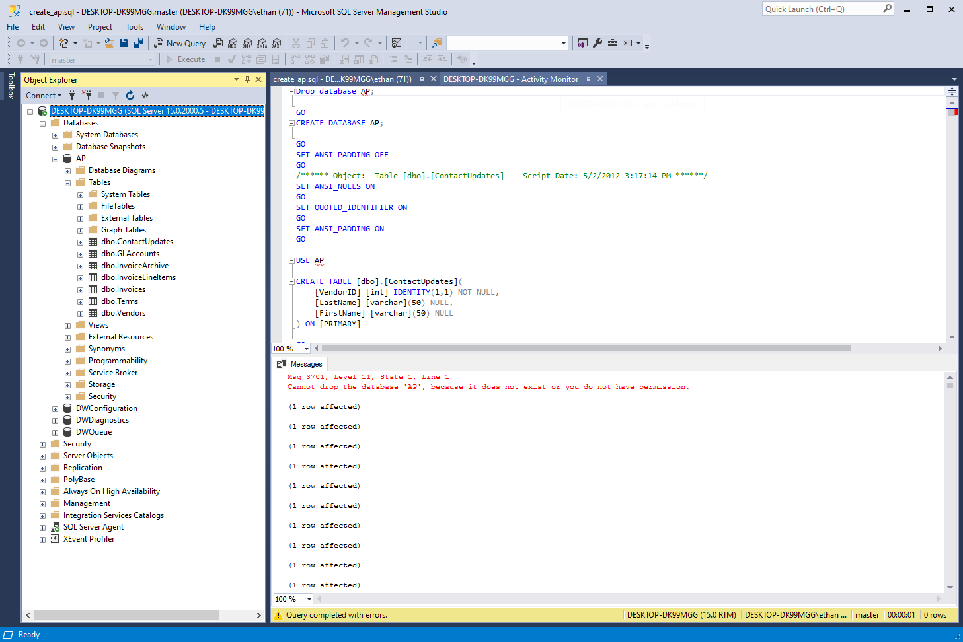

Murach SQL Server Management Studio My Guitar Shop Database Setup

In these exercises, you’ll use SQL Server Management Studio to create the MyGuitarShop database, to review the tables in the MyGuitarShop database, and to enter SQL statements and run them against this database.

Create the database

1. Start SQL Server Management Studio and open a connection using either Windows or SQL Server authentication.
2. Open the script file named CreateMyGuitarShop.sql that’s in the Exercise Starts directory by clicking the Open File button in the toolbar and then using the resulting dialog box to locate and open the file.
3. Execute the entire script by clicking the Execute button in the SQL Editor toolbar or by pressing F5. When you do, the Messages tab displays indicates whether the script executed successfully.

Review the database

1. In the Object Explorer window, expand the node for the database named MyGuitarShop so you can see all of the database objects it contains. If it isn’t displayed in the Object Explorer window, you may need to click on the Refresh button to display it.
2. View the data for the Categories and Products tables.
3. Navigate through the database objects and view the column definitions for at least the Categories and Products tables.

Enter and run SQL statements

1. Select the MyGuitarShop database from the Available Databases dropdown menu (Crtl + U) to choose it as the default database.
2. Open a new Query Editor window. Then, enter and run this SQL statement:

SELECT ProductName FROM Products

1. Delete the e at the end of ProductName and run the statement again. Note the error number and the description of the error.
2. Open another Query Editor window by clicking the New Query button. Then, enter and run this statement:

SELECT COUNT(*) AS NumberOfProducts

FROM Products

1. To show you’ve completed this activity, paste a screen print under this question of the SQL Server Object Explorer pane with the MyGuitarShop Tables folder expanded.

Paste your screen print here.

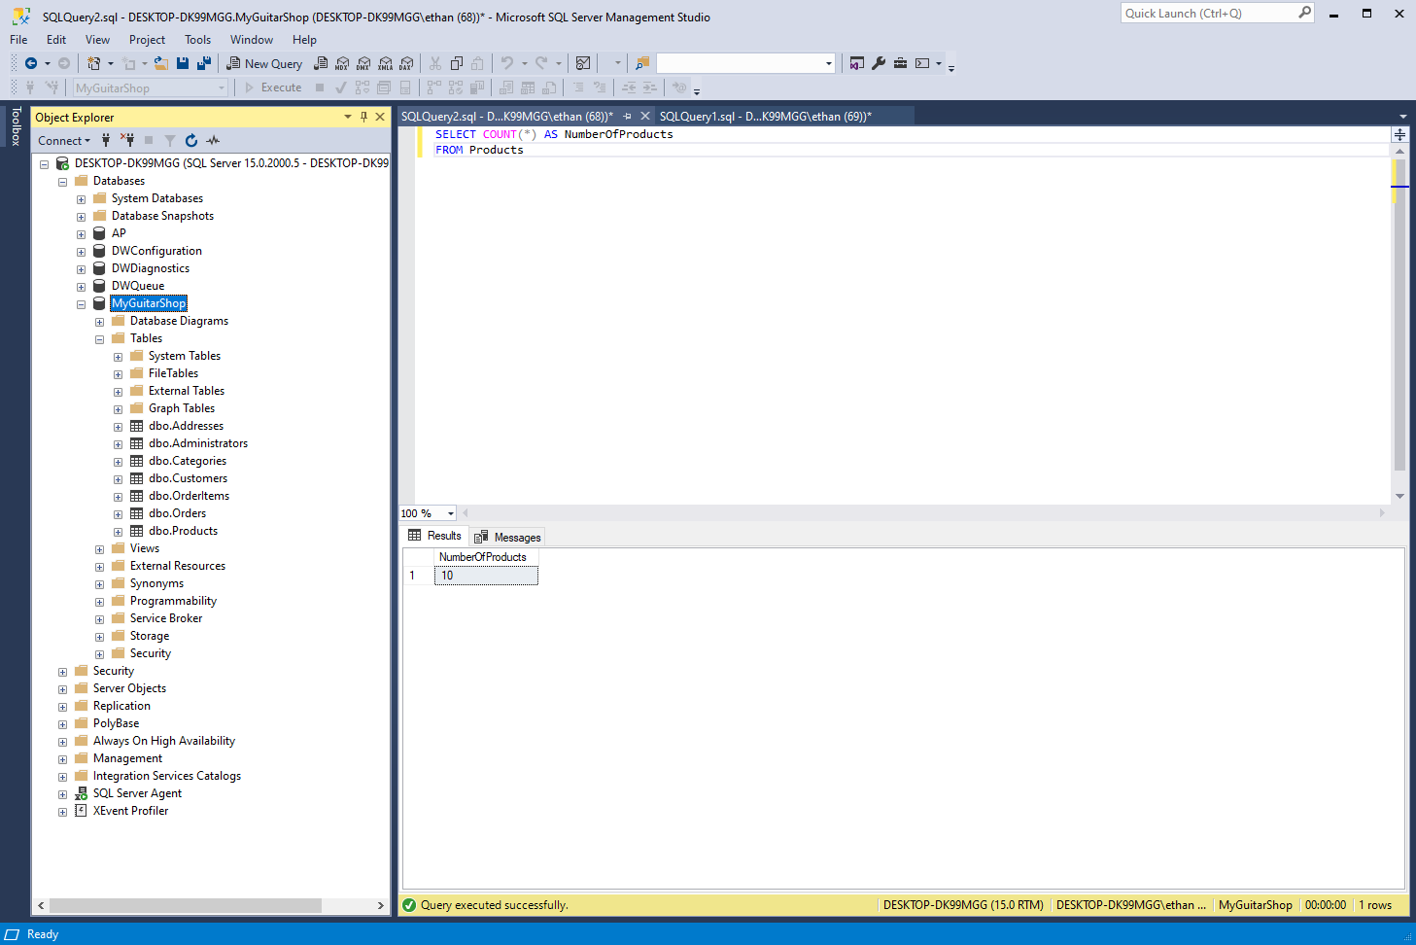

Install ERD Development Tool

**Pick an ERD Tool of your choosing. Suggested applications include Visual Paradigm OR Microsoft Visio If you would like to use Microsoft Visio, you can download it from your Microsoft Alliance Azure account. Visual Paradigm instructions can be found in Canvas under Module 1.**